# PART A

**1)**Variable names can range from 1 to 255 characters . Must begin with _ or a alphabet capital or small.Spaces or special characters not allowed.We cannot use c++ keyword as an identifier.

**2)**The largest use void data type is create generic pointers. If we don’t know to what type of datatype the pointer points , we can use these generic pointers. But type casting is required while usage.

Int i=10;

Void *gp;gp=&I;

Cout<<(int)*gp;

**3)** An enumeration is a user-defined data type consists of integral constants and each integral constant is give a name. Basically used for creation of symbolic constants.

enum boolean{ false;

true; };

enum boolean check;

**4)**Array is collection of similar homogenous data types;

Ex:-

Char name[100];

Name is array of 100 characters.

Since an array is derived from the primitive data types , it is known as derived data type .

**5)**In C++ a variable can be declared anywhere in the scope of the program. This feature is highly beneficial as at the time of writing the program , we don’t know how many variables can gonna be necessary , hence during the middle of the program , the declaration of new variables is helpful.

:: scope resolution operator can be used to access the global definition of a variable .

**6)**A reference variable provides an alias ( alternative name ) for a previously defined variable .

Its major use is in call by reference mechanism and return by reference mechanism , with these mechanisms the original data might be differed by other functions.

Ex:

Int &x=a;

Both x,a are hold the same address . or both are one and the same.

**7)**class

Public

Private

Inline

Namespace

New

Delete

**8)**

:: scope resolution operator

It is used to define a member function of a class outside the class.

It is used to access the global version of a variable.

**9)**

new is an operator whereas malloc()is function hence saves time.

There is no type casting required in new , where as in (int *)malloc() type casting is required since it returns a void pointer.

Syntax of new is rather easier.

Int *p=new int;

**10)**

char * const p;

this is a constant pointer , which means the address pointed by the pointer cannot be changed .

but the value at address can be changed .

that implies

char ch;

p=&ch; //illegal

*p=’x’; //legal

char const *p;

this is a pointer to a constant ,which means the address pointed by the pointer can changed but not the value at address.

That implies

Char ch;

P=&ch ; //legal

*p=’x’; //illegal

## PART B

**3.1)**

ALGORITHM:-

1)read two numbers

2)call the function swap

3)print the values after swap

Function:-

void swap(int &x,int &y)

{

int t=x;

x=y;

y=t;

}

Return type is void.

Takes two parameters as reference variables.

/*Function program to swap the values of a pair of integers using reference variables. Developed by Sekhar Karedla of BE ¼ CSE-2, CBIT */

#include<iostream>

using namespace std;

void swap(int &x,int &y) //function defination

{

int t=x;

x=y;

y=t;

}

int main()

{

cout<<"enter two numbers : "; //reading numbers

int a,b;

cin>>a>>b;

swap(a,b);

cout<<"after swapping : "<<a<<" "<<b; //displaying numbers

return 1;

}

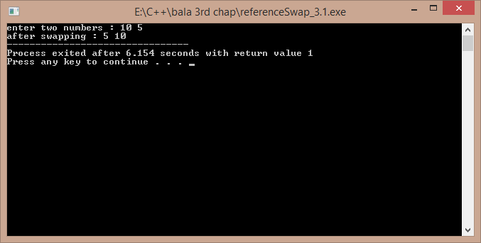

**3.2)**

ALGORITHM:-

1)read the size of vector from the user

2)create the vector using new operator

3)display the default values so as to show the created vector

/*A program to create a vector of size as demanded by the user , Developed by Sekhar Karedla BE ¼ CSE-2,CBIT*/

#include<iostream>

using namespace std;

int main()

{

int m,i;

cout<<"enter the size of vector : ";

cin>>m; //reading size

int *p=new int[m]; //creating the vector

cout<<"the garbage values are : \n";

for(i=0;i<m;i++) //displaying the garbage values

{

cout<<p[i]<<"\n";

}

return 1;

}

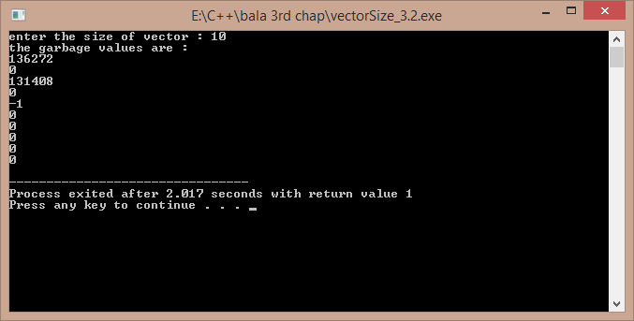

**3.3)**

ALGORITHM:-

1)start

2)read the number of lines from user

3)use two for loops to get the pattern

4)end

/*A program to display the following pattern

1

22

333

4444

55555

……

, Developed by Sekhar Karedla BE ¼ CSE-2,CBIT*/

#include<iostream>

using namespace std;

int main()

{

int i,j,m;

cout<<"enter the no of lines : ";

cin>>m;

for(i=1;i<=m;i++)

{

for(j=1;j<=i;j++)

{

cout<<i;

}

cout<<"\n";

}

return 1;

}

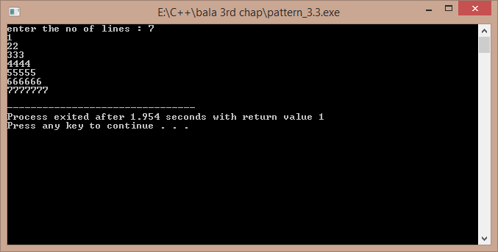

**3.4)**

ALGORITHM:-

1)start

2)take all the values in float

3)create three loops , one for the increment of p , one for r , one for n (nested loops)

4) calculate the value of v in each case using pow function under cmath header file

5)store the obtained data in a file so as for the convenience of the user to display the output

Mainly using fprintf() function.

6)end

/*A program to develop the results of the investment equation v=(1+p)^n. Developed by Sekhar Karedla BE ¼ CSE-2,CBIT*/

#include<iostream>

#include<cmath>

using namespace std;

int main()

{

float p,v,n,r;FILE *fp;char ch;

fp=fopen("result3.4.txt","w"); //opening a file

fputs("3.4 PROBLEM REULTS \n ---------------------------------------------------------------- \n",fp); //to initiate with the file some basic borders

fputs("P\t\tr\t\tn\t\t\tV\n",fp);

for(p=1000;p<=10000;p=p+1000)

{

for(r=0.10;r<=0.21;r=r+0.01)

{

for(n=1;n<=10;n++)

{

v=p*(pow((1+r),n)); //calculating v and storing in file the next line

fprintf(fp,"\n%f\t%f\t%f\t\t%f",p,r,n,v);

}

}

}

fclose(fp);

cout<<"the results have been stored int the text file result3.4.txt .";

return 1;

}

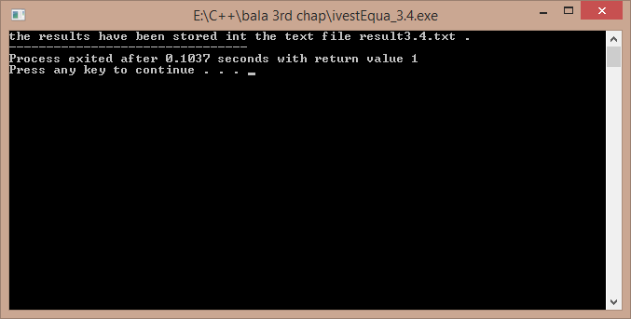

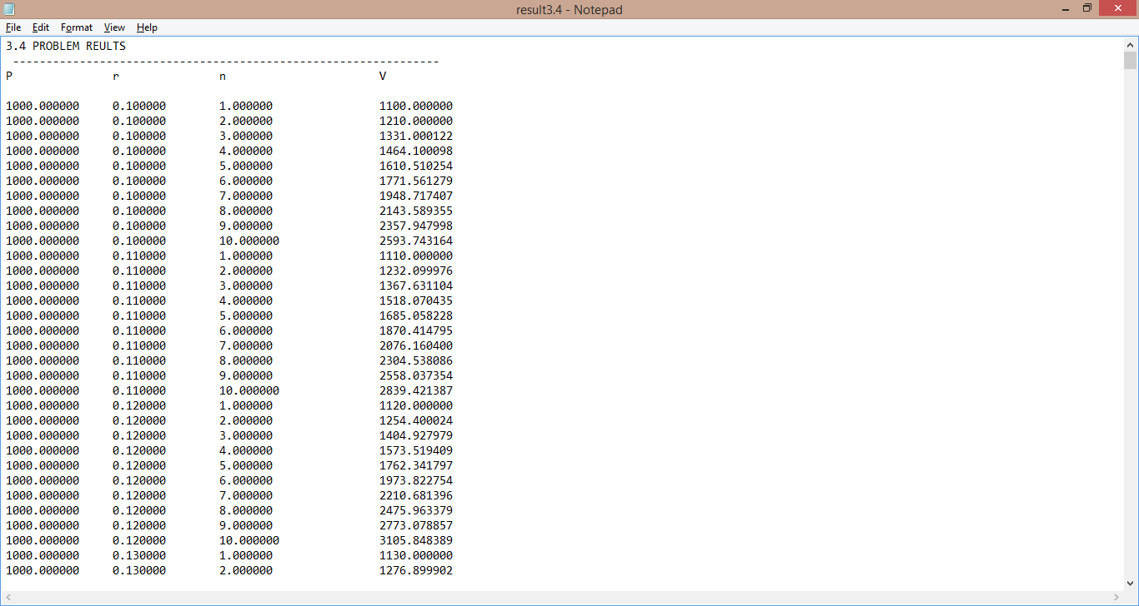

***THE CONTENTS OF THE FILE(RESULT3.4.txt) ARE:-***

3.4 PROBLEM REULTS

----------------------------------------------------------------

P r n V

1000.000000 0.100000 1.000000 1100.000000

1000.000000 0.100000 2.000000 1210.000000

1000.000000 0.100000 3.000000 1331.000122

1000.000000 0.100000 4.000000 1464.100098

1000.000000 0.100000 5.000000 1610.510254

1000.000000 0.100000 6.000000 1771.561279

1000.000000 0.100000 7.000000 1948.717407

1000.000000 0.100000 8.000000 2143.589355

1000.000000 0.100000 9.000000 2357.947998

1000.000000 0.100000 10.000000 2593.743164

1000.000000 0.110000 1.000000 1110.000000

1000.000000 0.110000 2.000000 1232.099976

1000.000000 0.110000 3.000000 1367.631104

1000.000000 0.110000 4.000000 1518.070435

1000.000000 0.110000 5.000000 1685.058228

1000.000000 0.110000 6.000000 1870.414795

1000.000000 0.110000 7.000000 2076.160400

1000.000000 0.110000 8.000000 2304.538086

1000.000000 0.110000 9.000000 2558.037354

1000.000000 0.110000 10.000000 2839.421387

1000.000000 0.120000 1.000000 1120.000000

1000.000000 0.120000 2.000000 1254.400024

1000.000000 0.120000 3.000000 1404.927979

1000.000000 0.120000 4.000000 1573.519409

1000.000000 0.120000 5.000000 1762.341797

1000.000000 0.120000 6.000000 1973.822754

1000.000000 0.120000 7.000000 2210.681396

1000.000000 0.120000 8.000000 2475.963379

1000.000000 0.120000 9.000000 2773.078857

1000.000000 0.120000 10.000000 3105.848389

1000.000000 0.130000 1.000000 1130.000000

1000.000000 0.130000 2.000000 1276.899902

1000.000000 0.130000 3.000000 1442.896973

1000.000000 0.130000 4.000000 1630.473633

1000.000000 0.130000 5.000000 1842.435181

1000.000000 0.130000 6.000000 2081.951660

1000.000000 0.130000 7.000000 2352.605225

1000.000000 0.130000 8.000000 2658.444092

1000.000000 0.130000 9.000000 3004.041992

1000.000000 0.130000 10.000000 3394.567139

1000.000000 0.140000 1.000000 1140.000000

1000.000000 0.140000 2.000000 1299.599976

1000.000000 0.140000 3.000000 1481.543945

1000.000000 0.140000 4.000000 1688.960083

1000.000000 0.140000 5.000000 1925.414429

1000.000000 0.140000 6.000000 2194.972412

1000.000000 0.140000 7.000000 2502.268555

1000.000000 0.140000 8.000000 2852.585938

1000.000000 0.140000 9.000000 3251.947998

1000.000000 0.140000 10.000000 3707.220703

1000.000000 0.150000 1.000000 1150.000000

1000.000000 0.150000 2.000000 1322.500000

1000.000000 0.150000 3.000000 1520.874878

1000.000000 0.150000 4.000000 1749.006104

1000.000000 0.150000 5.000000 2011.357056

1000.000000 0.150000 6.000000 2313.060547

1000.000000 0.150000 7.000000 2660.019287

1000.000000 0.150000 8.000000 3059.022461

1000.000000 0.150000 9.000000 3517.875732

1000.000000 0.150000 10.000000 4045.557129

1000.000000 0.160000 1.000000 1160.000000

1000.000000 0.160000 2.000000 1345.599854

1000.000000 0.160000 3.000000 1560.895874

1000.000000 0.160000 4.000000 1810.639160

1000.000000 0.160000 5.000000 2100.341309

1000.000000 0.160000 6.000000 2436.395996

1000.000000 0.160000 7.000000 2826.218994

1000.000000 0.160000 8.000000 3278.414307

1000.000000 0.160000 9.000000 3802.960449

1000.000000 0.160000 10.000000 4411.433594

1000.000000 0.170000 1.000000 1170.000122

1000.000000 0.170000 2.000000 1368.900146

1000.000000 0.170000 3.000000 1601.613281

1000.000000 0.170000 4.000000 1873.887695

1000.000000 0.170000 5.000000 2192.448975

1000.000000 0.170000 6.000000 2565.165283

1000.000000 0.170000 7.000000 3001.243652

1000.000000 0.170000 8.000000 3511.455078

1000.000000 0.170000 9.000000 4108.402832

1000.000000 0.170000 10.000000 4806.831543

1000.000000 0.180000 1.000000 1180.000122

1000.000000 0.180000 2.000000 1392.400146

1000.000000 0.180000 3.000000 1643.032349

1000.000000 0.180000 4.000000 1938.778198

1000.000000 0.180000 5.000000 2287.758301

1000.000000 0.180000 6.000000 2699.555176

1000.000000 0.180000 7.000000 3185.475098

1000.000000 0.180000 8.000000 3758.860840

1000.000000 0.180000 9.000000 4435.456055

1000.000000 0.180000 10.000000 5233.838379

1000.000000 0.190000 1.000000 1190.000000

1000.000000 0.190000 2.000000 1416.100098

1000.000000 0.190000 3.000000 1685.159180

1000.000000 0.190000 4.000000 2005.339600

1000.000000 0.190000 5.000000 2386.354248

1000.000000 0.190000 6.000000 2839.761719

1000.000000 0.190000 7.000000 3379.316650

1000.000000 0.190000 8.000000 4021.387207

1000.000000 0.190000 9.000000 4785.450684

1000.000000 0.190000 10.000000 5694.686523

1000.000000 0.200000 1.000000 1200.000000

1000.000000 0.200000 2.000000 1440.000000

1000.000000 0.200000 3.000000 1728.000122

1000.000000 0.200000 4.000000 2073.600342

1000.000000 0.200000 5.000000 2488.320557

1000.000000 0.200000 6.000000 2985.984863

1000.000000 0.200000 7.000000 3583.181885

1000.000000 0.200000 8.000000 4299.818359

1000.000000 0.200000 9.000000 5159.782227

1000.000000 0.200000 10.000000 6191.739258

2000.000000 0.100000 1.000000 2200.000000

2000.000000 0.100000 2.000000 2420.000000

2000.000000 0.100000 3.000000 2662.000244

2000.000000 0.100000 4.000000 2928.200195

2000.000000 0.100000 5.000000 3221.020508

2000.000000 0.100000 6.000000 3543.122559

2000.000000 0.100000 7.000000 3897.434814

2000.000000 0.100000 8.000000 4287.178711

2000.000000 0.100000 9.000000 4715.895996

2000.000000 0.100000 10.000000 5187.486328

2000.000000 0.110000 1.000000 2220.000000

2000.000000 0.110000 2.000000 2464.199951

2000.000000 0.110000 3.000000 2735.262207

2000.000000 0.110000 4.000000 3036.140869

2000.000000 0.110000 5.000000 3370.116455

2000.000000 0.110000 6.000000 3740.829590

2000.000000 0.110000 7.000000 4152.320801

2000.000000 0.110000 8.000000 4609.076172

2000.000000 0.110000 9.000000 5116.074707

2000.000000 0.110000 10.000000 5678.842773

2000.000000 0.120000 1.000000 2240.000000

2000.000000 0.120000 2.000000 2508.800049

2000.000000 0.120000 3.000000 2809.855957

2000.000000 0.120000 4.000000 3147.038818

2000.000000 0.120000 5.000000 3524.683594

2000.000000 0.120000 6.000000 3947.645508

2000.000000 0.120000 7.000000 4421.362793

2000.000000 0.120000 8.000000 4951.926758

2000.000000 0.120000 9.000000 5546.157715

2000.000000 0.120000 10.000000 6211.696777

2000.000000 0.130000 1.000000 2260.000000

2000.000000 0.130000 2.000000 2553.799805

2000.000000 0.130000 3.000000 2885.793945

2000.000000 0.130000 4.000000 3260.947266

2000.000000 0.130000 5.000000 3684.870361

2000.000000 0.130000 6.000000 4163.903320

2000.000000 0.130000 7.000000 4705.210449

2000.000000 0.130000 8.000000 5316.888184

2000.000000 0.130000 9.000000 6008.083984

2000.000000 0.130000 10.000000 6789.134277

2000.000000 0.140000 1.000000 2280.000000

2000.000000 0.140000 2.000000 2599.199951

2000.000000 0.140000 3.000000 2963.087891

2000.000000 0.140000 4.000000 3377.920166

2000.000000 0.140000 5.000000 3850.828857

2000.000000 0.140000 6.000000 4389.944824

2000.000000 0.140000 7.000000 5004.537109

2000.000000 0.140000 8.000000 5705.171875

2000.000000 0.140000 9.000000 6503.895996

2000.000000 0.140000 10.000000 7414.441406

2000.000000 0.150000 1.000000 2300.000000

2000.000000 0.150000 2.000000 2645.000000

2000.000000 0.150000 3.000000 3041.749756

2000.000000 0.150000 4.000000 3498.012207

2000.000000 0.150000 5.000000 4022.714111

2000.000000 0.150000 6.000000 4626.121094

2000.000000 0.150000 7.000000 5320.038574

2000.000000 0.150000 8.000000 6118.044922

2000.000000 0.150000 9.000000 7035.751465

2000.000000 0.150000 10.000000 8091.114258

2000.000000 0.160000 1.000000 2320.000000

2000.000000 0.160000 2.000000 2691.199707

2000.000000 0.160000 3.000000 3121.791748

2000.000000 0.160000 4.000000 3621.278320

2000.000000 0.160000 5.000000 4200.682617

2000.000000 0.160000 6.000000 4872.791992

2000.000000 0.160000 7.000000 5652.437988

2000.000000 0.160000 8.000000 6556.828613

2000.000000 0.160000 9.000000 7605.920898

2000.000000 0.160000 10.000000 8822.867188

2000.000000 0.170000 1.000000 2340.000244

2000.000000 0.170000 2.000000 2737.800293

2000.000000 0.170000 3.000000 3203.226562

2000.000000 0.170000 4.000000 3747.775391

2000.000000 0.170000 5.000000 4384.897949

2000.000000 0.170000 6.000000 5130.330566

2000.000000 0.170000 7.000000 6002.487305

2000.000000 0.170000 8.000000 7022.910156

2000.000000 0.170000 9.000000 8216.805664

2000.000000 0.170000 10.000000 9613.663086

2000.000000 0.180000 1.000000 2360.000244

2000.000000 0.180000 2.000000 2784.800293

2000.000000 0.180000 3.000000 3286.064697

2000.000000 0.180000 4.000000 3877.556396

2000.000000 0.180000 5.000000 4575.516602

2000.000000 0.180000 6.000000 5399.110352

2000.000000 0.180000 7.000000 6370.950195

2000.000000 0.180000 8.000000 7517.721680

2000.000000 0.180000 9.000000 8870.912109

2000.000000 0.180000 10.000000 10467.676758

2000.000000 0.190000 1.000000 2380.000000

2000.000000 0.190000 2.000000 2832.200195

2000.000000 0.190000 3.000000 3370.318359

2000.000000 0.190000 4.000000 4010.679199

2000.000000 0.190000 5.000000 4772.708496

2000.000000 0.190000 6.000000 5679.523438

2000.000000 0.190000 7.000000 6758.633301

2000.000000 0.190000 8.000000 8042.774414

2000.000000 0.190000 9.000000 9570.901367

2000.000000 0.190000 10.000000 11389.373047

2000.000000 0.200000 1.000000 2400.000000

2000.000000 0.200000 2.000000 2880.000000

2000.000000 0.200000 3.000000 3456.000244

2000.000000 0.200000 4.000000 4147.200684

2000.000000 0.200000 5.000000 4976.641113

2000.000000 0.200000 6.000000 5971.969727

2000.000000 0.200000 7.000000 7166.363770

2000.000000 0.200000 8.000000 8599.636719

2000.000000 0.200000 9.000000 10319.564453

2000.000000 0.200000 10.000000 12383.478516

3000.000000 0.100000 1.000000 3300.000000

3000.000000 0.100000 2.000000 3630.000000

3000.000000 0.100000 3.000000 3993.000244

3000.000000 0.100000 4.000000 4392.300293

3000.000000 0.100000 5.000000 4831.530762

3000.000000 0.100000 6.000000 5314.683594

3000.000000 0.100000 7.000000 5846.151855

3000.000000 0.100000 8.000000 6430.767578

3000.000000 0.100000 9.000000 7073.844238

3000.000000 0.100000 10.000000 7781.229492

3000.000000 0.110000 1.000000 3330.000000

3000.000000 0.110000 2.000000 3696.300049

3000.000000 0.110000 3.000000 4102.893066

3000.000000 0.110000 4.000000 4554.211426

3000.000000 0.110000 5.000000 5055.174805

3000.000000 0.110000 6.000000 5611.244141

3000.000000 0.110000 7.000000 6228.481445

3000.000000 0.110000 8.000000 6913.614258

3000.000000 0.110000 9.000000 7674.111816

3000.000000 0.110000 10.000000 8518.263672

3000.000000 0.120000 1.000000 3360.000000

3000.000000 0.120000 2.000000 3763.199951

3000.000000 0.120000 3.000000 4214.783691

3000.000000 0.120000 4.000000 4720.558105

3000.000000 0.120000 5.000000 5287.025391

3000.000000 0.120000 6.000000 5921.468262

3000.000000 0.120000 7.000000 6632.044434

3000.000000 0.120000 8.000000 7427.890137

3000.000000 0.120000 9.000000 8319.236328

3000.000000 0.120000 10.000000 9317.544922

3000.000000 0.130000 1.000000 3390.000000

3000.000000 0.130000 2.000000 3830.699707

3000.000000 0.130000 3.000000 4328.690918

3000.000000 0.130000 4.000000 4891.420898

3000.000000 0.130000 5.000000 5527.305176

3000.000000 0.130000 6.000000 6245.854980

3000.000000 0.130000 7.000000 7057.815918

3000.000000 0.130000 8.000000 7975.332520

3000.000000 0.130000 9.000000 9012.125977

3000.000000 0.130000 10.000000 10183.702148

3000.000000 0.140000 1.000000 3420.000000

3000.000000 0.140000 2.000000 3898.800049

3000.000000 0.140000 3.000000 4444.631836

3000.000000 0.140000 4.000000 5066.880371

3000.000000 0.140000 5.000000 5776.243164

3000.000000 0.140000 6.000000 6584.917480

3000.000000 0.140000 7.000000 7506.805664

3000.000000 0.140000 8.000000 8557.757812

3000.000000 0.140000 9.000000 9755.844727

3000.000000 0.140000 10.000000 11121.662109

3000.000000 0.150000 1.000000 3450.000000

3000.000000 0.150000 2.000000 3967.500000

3000.000000 0.150000 3.000000 4562.624512

3000.000000 0.150000 4.000000 5247.018555

3000.000000 0.150000 5.000000 6034.071289

3000.000000 0.150000 6.000000 6939.181641

3000.000000 0.150000 7.000000 7980.058105

3000.000000 0.150000 8.000000 9177.067383

3000.000000 0.150000 9.000000 10553.626953

3000.000000 0.150000 10.000000 12136.670898

3000.000000 0.160000 1.000000 3480.000000

3000.000000 0.160000 2.000000 4036.799561

3000.000000 0.160000 3.000000 4682.687988

3000.000000 0.160000 4.000000 5431.917480

3000.000000 0.160000 5.000000 6301.023926

3000.000000 0.160000 6.000000 7309.187500

3000.000000 0.160000 7.000000 8478.657227

3000.000000 0.160000 8.000000 9835.243164

3000.000000 0.160000 9.000000 11408.880859

3000.000000 0.160000 10.000000 13234.300781

3000.000000 0.170000 1.000000 3510.000244

3000.000000 0.170000 2.000000 4106.700684

3000.000000 0.170000 3.000000 4804.839844

3000.000000 0.170000 4.000000 5621.663086

3000.000000 0.170000 5.000000 6577.346680

3000.000000 0.170000 6.000000 7695.495605

3000.000000 0.170000 7.000000 9003.730469

3000.000000 0.170000 8.000000 10534.365234

3000.000000 0.170000 9.000000 12325.208008

3000.000000 0.170000 10.000000 14420.494141

3000.000000 0.180000 1.000000 3540.000244

3000.000000 0.180000 2.000000 4177.200195

3000.000000 0.180000 3.000000 4929.097168

3000.000000 0.180000 4.000000 5816.334473

3000.000000 0.180000 5.000000 6863.274902

3000.000000 0.180000 6.000000 8098.665527

3000.000000 0.180000 7.000000 9556.425781

3000.000000 0.180000 8.000000 11276.582031

3000.000000 0.180000 9.000000 13306.369141

3000.000000 0.180000 10.000000 15701.515625

3000.000000 0.190000 1.000000 3570.000244

3000.000000 0.190000 2.000000 4248.300293

3000.000000 0.190000 3.000000 5055.477539

3000.000000 0.190000 4.000000 6016.019043

3000.000000 0.190000 5.000000 7159.062500

3000.000000 0.190000 6.000000 8519.285156

3000.000000 0.190000 7.000000 10137.949219

3000.000000 0.190000 8.000000 12064.161133

3000.000000 0.190000 9.000000 14356.351562

3000.000000 0.190000 10.000000 17084.058594

3000.000000 0.200000 1.000000 3600.000244

3000.000000 0.200000 2.000000 4320.000000

3000.000000 0.200000 3.000000 5184.000488

3000.000000 0.200000 4.000000 6220.800781

3000.000000 0.200000 5.000000 7464.961914

3000.000000 0.200000 6.000000 8957.954102

3000.000000 0.200000 7.000000 10749.545898

3000.000000 0.200000 8.000000 12899.455078

3000.000000 0.200000 9.000000 15479.347656

3000.000000 0.200000 10.000000 18575.216797

4000.000000 0.100000 1.000000 4400.000000

4000.000000 0.100000 2.000000 4840.000000

4000.000000 0.100000 3.000000 5324.000488

4000.000000 0.100000 4.000000 5856.400391

4000.000000 0.100000 5.000000 6442.041016

4000.000000 0.100000 6.000000 7086.245117

4000.000000 0.100000 7.000000 7794.869629

4000.000000 0.100000 8.000000 8574.357422

4000.000000 0.100000 9.000000 9431.791992

4000.000000 0.100000 10.000000 10374.972656

4000.000000 0.110000 1.000000 4440.000000

4000.000000 0.110000 2.000000 4928.399902

4000.000000 0.110000 3.000000 5470.524414

4000.000000 0.110000 4.000000 6072.281738

4000.000000 0.110000 5.000000 6740.232910

4000.000000 0.110000 6.000000 7481.659180

4000.000000 0.110000 7.000000 8304.641602

4000.000000 0.110000 8.000000 9218.152344

4000.000000 0.110000 9.000000 10232.149414

4000.000000 0.110000 10.000000 11357.685547

4000.000000 0.120000 1.000000 4480.000000

4000.000000 0.120000 2.000000 5017.600098

4000.000000 0.120000 3.000000 5619.711914

4000.000000 0.120000 4.000000 6294.077637

4000.000000 0.120000 5.000000 7049.367188

4000.000000 0.120000 6.000000 7895.291016

4000.000000 0.120000 7.000000 8842.725586

4000.000000 0.120000 8.000000 9903.853516

4000.000000 0.120000 9.000000 11092.315430

4000.000000 0.120000 10.000000 12423.393555

4000.000000 0.130000 1.000000 4520.000000

4000.000000 0.130000 2.000000 5107.599609

4000.000000 0.130000 3.000000 5771.587891

4000.000000 0.130000 4.000000 6521.894531

4000.000000 0.130000 5.000000 7369.740723

4000.000000 0.130000 6.000000 8327.806641

4000.000000 0.130000 7.000000 9410.420898

4000.000000 0.130000 8.000000 10633.776367

4000.000000 0.130000 9.000000 12016.167969

4000.000000 0.130000 10.000000 13578.268555

4000.000000 0.140000 1.000000 4560.000000

4000.000000 0.140000 2.000000 5198.399902

4000.000000 0.140000 3.000000 5926.175781

4000.000000 0.140000 4.000000 6755.840332

4000.000000 0.140000 5.000000 7701.657715

4000.000000 0.140000 6.000000 8779.889648

4000.000000 0.140000 7.000000 10009.074219

4000.000000 0.140000 8.000000 11410.343750

4000.000000 0.140000 9.000000 13007.791992

4000.000000 0.140000 10.000000 14828.882812

4000.000000 0.150000 1.000000 4600.000000

4000.000000 0.150000 2.000000 5290.000000

4000.000000 0.150000 3.000000 6083.499512

4000.000000 0.150000 4.000000 6996.024414

4000.000000 0.150000 5.000000 8045.428223

4000.000000 0.150000 6.000000 9252.242188

4000.000000 0.150000 7.000000 10640.077148

4000.000000 0.150000 8.000000 12236.089844

4000.000000 0.150000 9.000000 14071.502930

4000.000000 0.150000 10.000000 16182.228516

4000.000000 0.160000 1.000000 4640.000000

4000.000000 0.160000 2.000000 5382.399414

4000.000000 0.160000 3.000000 6243.583496

4000.000000 0.160000 4.000000 7242.556641

4000.000000 0.160000 5.000000 8401.365234

4000.000000 0.160000 6.000000 9745.583984

4000.000000 0.160000 7.000000 11304.875977

4000.000000 0.160000 8.000000 13113.657227

4000.000000 0.160000 9.000000 15211.841797

4000.000000 0.160000 10.000000 17645.734375

4000.000000 0.170000 1.000000 4680.000488

4000.000000 0.170000 2.000000 5475.600586

4000.000000 0.170000 3.000000 6406.453125

4000.000000 0.170000 4.000000 7495.550781

4000.000000 0.170000 5.000000 8769.795898

4000.000000 0.170000 6.000000 10260.661133

4000.000000 0.170000 7.000000 12004.974609

4000.000000 0.170000 8.000000 14045.820312

4000.000000 0.170000 9.000000 16433.611328

4000.000000 0.170000 10.000000 19227.326172

4000.000000 0.180000 1.000000 4720.000488

4000.000000 0.180000 2.000000 5569.600586

4000.000000 0.180000 3.000000 6572.129395

4000.000000 0.180000 4.000000 7755.112793

4000.000000 0.180000 5.000000 9151.033203

4000.000000 0.180000 6.000000 10798.220703

4000.000000 0.180000 7.000000 12741.900391

4000.000000 0.180000 8.000000 15035.443359

4000.000000 0.180000 9.000000 17741.824219

4000.000000 0.180000 10.000000 20935.353516

4000.000000 0.190000 1.000000 4760.000000

4000.000000 0.190000 2.000000 5664.400391

4000.000000 0.190000 3.000000 6740.636719

4000.000000 0.190000 4.000000 8021.358398

4000.000000 0.190000 5.000000 9545.416992

4000.000000 0.190000 6.000000 11359.046875

4000.000000 0.190000 7.000000 13517.266602

4000.000000 0.190000 8.000000 16085.548828

4000.000000 0.190000 9.000000 19141.802734

4000.000000 0.190000 10.000000 22778.746094

4000.000000 0.200000 1.000000 4800.000000

4000.000000 0.200000 2.000000 5760.000000

4000.000000 0.200000 3.000000 6912.000488

4000.000000 0.200000 4.000000 8294.401367

4000.000000 0.200000 5.000000 9953.282227

4000.000000 0.200000 6.000000 11943.939453

4000.000000 0.200000 7.000000 14332.727539

4000.000000 0.200000 8.000000 17199.273438

4000.000000 0.200000 9.000000 20639.128906

4000.000000 0.200000 10.000000 24766.957031

5000.000000 0.100000 1.000000 5500.000000

5000.000000 0.100000 2.000000 6050.000000

5000.000000 0.100000 3.000000 6655.000488

5000.000000 0.100000 4.000000 7320.500488

5000.000000 0.100000 5.000000 8052.551270

5000.000000 0.100000 6.000000 8857.806641

5000.000000 0.100000 7.000000 9743.586914

5000.000000 0.100000 8.000000 10717.946289

5000.000000 0.100000 9.000000 11789.740234

5000.000000 0.100000 10.000000 12968.715820

5000.000000 0.110000 1.000000 5550.000000

5000.000000 0.110000 2.000000 6160.500000

5000.000000 0.110000 3.000000 6838.155273

5000.000000 0.110000 4.000000 7590.352539

5000.000000 0.110000 5.000000 8425.291016

5000.000000 0.110000 6.000000 9352.073242

5000.000000 0.110000 7.000000 10380.801758

5000.000000 0.110000 8.000000 11522.690430

5000.000000 0.110000 9.000000 12790.186523

5000.000000 0.110000 10.000000 14197.106445

5000.000000 0.120000 1.000000 5600.000000

5000.000000 0.120000 2.000000 6272.000000

5000.000000 0.120000 3.000000 7024.639648

5000.000000 0.120000 4.000000 7867.596680

5000.000000 0.120000 5.000000 8811.708984

5000.000000 0.120000 6.000000 9869.113281

5000.000000 0.120000 7.000000 11053.407227

5000.000000 0.120000 8.000000 12379.816406

5000.000000 0.120000 9.000000 13865.394531

5000.000000 0.120000 10.000000 15529.241211

5000.000000 0.130000 1.000000 5650.000000

5000.000000 0.130000 2.000000 6384.499512

5000.000000 0.130000 3.000000 7214.484863

5000.000000 0.130000 4.000000 8152.368164

5000.000000 0.130000 5.000000 9212.175781

5000.000000 0.130000 6.000000 10409.757812

5000.000000 0.130000 7.000000 11763.026367

5000.000000 0.130000 8.000000 13292.220703

5000.000000 0.130000 9.000000 15020.209961

5000.000000 0.130000 10.000000 16972.835938

5000.000000 0.140000 1.000000 5700.000000

5000.000000 0.140000 2.000000 6498.000000

5000.000000 0.140000 3.000000 7407.719727

5000.000000 0.140000 4.000000 8444.800781

5000.000000 0.140000 5.000000 9627.072266

5000.000000 0.140000 6.000000 10974.862305

5000.000000 0.140000 7.000000 12511.342773

5000.000000 0.140000 8.000000 14262.929688

5000.000000 0.140000 9.000000 16259.740234

5000.000000 0.140000 10.000000 18536.103516

5000.000000 0.150000 1.000000 5750.000000

5000.000000 0.150000 2.000000 6612.500000

5000.000000 0.150000 3.000000 7604.374512

5000.000000 0.150000 4.000000 8745.030273

5000.000000 0.150000 5.000000 10056.785156

5000.000000 0.150000 6.000000 11565.302734

5000.000000 0.150000 7.000000 13300.096680

5000.000000 0.150000 8.000000 15295.112305

5000.000000 0.150000 9.000000 17589.378906

5000.000000 0.150000 10.000000 20227.785156

5000.000000 0.160000 1.000000 5800.000000

5000.000000 0.160000 2.000000 6727.999512

5000.000000 0.160000 3.000000 7804.479492

5000.000000 0.160000 4.000000 9053.195312

5000.000000 0.160000 5.000000 10501.707031

5000.000000 0.160000 6.000000 12181.979492

5000.000000 0.160000 7.000000 14131.095703

5000.000000 0.160000 8.000000 16392.070312

5000.000000 0.160000 9.000000 19014.802734

5000.000000 0.160000 10.000000 22057.167969

5000.000000 0.170000 1.000000 5850.000488

5000.000000 0.170000 2.000000 6844.500977

5000.000000 0.170000 3.000000 8008.066406

5000.000000 0.170000 4.000000 9369.438477

5000.000000 0.170000 5.000000 10962.244141

5000.000000 0.170000 6.000000 12825.826172

5000.000000 0.170000 7.000000 15006.217773

5000.000000 0.170000 8.000000 17557.275391

5000.000000 0.170000 9.000000 20542.013672

5000.000000 0.170000 10.000000 24034.156250

5000.000000 0.180000 1.000000 5900.000488

5000.000000 0.180000 2.000000 6962.000488

5000.000000 0.180000 3.000000 8215.161133

5000.000000 0.180000 4.000000 9693.890625

5000.000000 0.180000 5.000000 11438.791992

5000.000000 0.180000 6.000000 13497.775391

5000.000000 0.180000 7.000000 15927.375977

5000.000000 0.180000 8.000000 18794.304688

5000.000000 0.180000 9.000000 22177.281250

5000.000000 0.180000 10.000000 26169.193359

5000.000000 0.190000 1.000000 5950.000488

5000.000000 0.190000 2.000000 7080.500488

5000.000000 0.190000 3.000000 8425.795898

5000.000000 0.190000 4.000000 10026.698242

5000.000000 0.190000 5.000000 11931.771484

5000.000000 0.190000 6.000000 14198.808594

5000.000000 0.190000 7.000000 16896.582031

5000.000000 0.190000 8.000000 20106.935547

5000.000000 0.190000 9.000000 23927.251953

5000.000000 0.190000 10.000000 28473.431641

5000.000000 0.200000 1.000000 6000.000000

5000.000000 0.200000 2.000000 7200.000488

5000.000000 0.200000 3.000000 8640.000977

5000.000000 0.200000 4.000000 10368.000977

5000.000000 0.200000 5.000000 12441.602539

5000.000000 0.200000 6.000000 14929.923828

5000.000000 0.200000 7.000000 17915.910156

5000.000000 0.200000 8.000000 21499.091797

5000.000000 0.200000 9.000000 25798.912109

5000.000000 0.200000 10.000000 30958.695312

6000.000000 0.100000 1.000000 6600.000000

6000.000000 0.100000 2.000000 7260.000000

6000.000000 0.100000 3.000000 7986.000488

6000.000000 0.100000 4.000000 8784.600586

6000.000000 0.100000 5.000000 9663.061523

6000.000000 0.100000 6.000000 10629.367188

6000.000000 0.100000 7.000000 11692.303711

6000.000000 0.100000 8.000000 12861.535156

6000.000000 0.100000 9.000000 14147.688477

6000.000000 0.100000 10.000000 15562.458984

6000.000000 0.110000 1.000000 6660.000000

6000.000000 0.110000 2.000000 7392.600098

6000.000000 0.110000 3.000000 8205.786133

6000.000000 0.110000 4.000000 9108.422852

6000.000000 0.110000 5.000000 10110.349609

6000.000000 0.110000 6.000000 11222.488281

6000.000000 0.110000 7.000000 12456.962891

6000.000000 0.110000 8.000000 13827.228516

6000.000000 0.110000 9.000000 15348.223633

6000.000000 0.110000 10.000000 17036.527344

6000.000000 0.120000 1.000000 6720.000000

6000.000000 0.120000 2.000000 7526.399902

6000.000000 0.120000 3.000000 8429.567383

6000.000000 0.120000 4.000000 9441.116211

6000.000000 0.120000 5.000000 10574.050781

6000.000000 0.120000 6.000000 11842.936523

6000.000000 0.120000 7.000000 13264.088867

6000.000000 0.120000 8.000000 14855.780273

6000.000000 0.120000 9.000000 16638.472656

6000.000000 0.120000 10.000000 18635.089844

6000.000000 0.130000 1.000000 6780.000000

6000.000000 0.130000 2.000000 7661.399414

6000.000000 0.130000 3.000000 8657.381836

6000.000000 0.130000 4.000000 9782.841797

6000.000000 0.130000 5.000000 11054.610352

6000.000000 0.130000 6.000000 12491.709961

6000.000000 0.130000 7.000000 14115.631836

6000.000000 0.130000 8.000000 15950.665039

6000.000000 0.130000 9.000000 18024.251953

6000.000000 0.130000 10.000000 20367.404297

6000.000000 0.140000 1.000000 6840.000000

6000.000000 0.140000 2.000000 7797.600098

6000.000000 0.140000 3.000000 8889.263672

6000.000000 0.140000 4.000000 10133.760742

6000.000000 0.140000 5.000000 11552.486328

6000.000000 0.140000 6.000000 13169.834961

6000.000000 0.140000 7.000000 15013.611328

6000.000000 0.140000 8.000000 17115.515625

6000.000000 0.140000 9.000000 19511.689453

6000.000000 0.140000 10.000000 22243.324219

6000.000000 0.150000 1.000000 6900.000000

6000.000000 0.150000 2.000000 7935.000000

6000.000000 0.150000 3.000000 9125.249023

6000.000000 0.150000 4.000000 10494.037109

6000.000000 0.150000 5.000000 12068.142578

6000.000000 0.150000 6.000000 13878.363281

6000.000000 0.150000 7.000000 15960.116211

6000.000000 0.150000 8.000000 18354.134766

6000.000000 0.150000 9.000000 21107.253906

6000.000000 0.150000 10.000000 24273.341797

6000.000000 0.160000 1.000000 6960.000000

6000.000000 0.160000 2.000000 8073.599121

6000.000000 0.160000 3.000000 9365.375977

6000.000000 0.160000 4.000000 10863.834961

6000.000000 0.160000 5.000000 12602.047852

6000.000000 0.160000 6.000000 14618.375000

6000.000000 0.160000 7.000000 16957.314453

6000.000000 0.160000 8.000000 19670.486328

6000.000000 0.160000 9.000000 22817.761719

6000.000000 0.160000 10.000000 26468.601562

6000.000000 0.170000 1.000000 7020.000488

6000.000000 0.170000 2.000000 8213.401367

6000.000000 0.170000 3.000000 9609.679688

6000.000000 0.170000 4.000000 11243.326172

6000.000000 0.170000 5.000000 13154.693359

6000.000000 0.170000 6.000000 15390.991211

6000.000000 0.170000 7.000000 18007.460938

6000.000000 0.170000 8.000000 21068.730469

6000.000000 0.170000 9.000000 24650.416016

6000.000000 0.170000 10.000000 28840.988281

6000.000000 0.180000 1.000000 7080.000488

6000.000000 0.180000 2.000000 8354.400391

6000.000000 0.180000 3.000000 9858.194336

6000.000000 0.180000 4.000000 11632.668945

6000.000000 0.180000 5.000000 13726.549805

6000.000000 0.180000 6.000000 16197.331055

6000.000000 0.180000 7.000000 19112.851562

6000.000000 0.180000 8.000000 22553.164062

6000.000000 0.180000 9.000000 26612.738281

6000.000000 0.180000 10.000000 31403.031250

6000.000000 0.190000 1.000000 7140.000488

6000.000000 0.190000 2.000000 8496.600586

6000.000000 0.190000 3.000000 10110.955078

6000.000000 0.190000 4.000000 12032.038086

6000.000000 0.190000 5.000000 14318.125000

6000.000000 0.190000 6.000000 17038.570312

6000.000000 0.190000 7.000000 20275.898438

6000.000000 0.190000 8.000000 24128.322266

6000.000000 0.190000 9.000000 28712.703125

6000.000000 0.190000 10.000000 34168.117188

6000.000000 0.200000 1.000000 7200.000488

6000.000000 0.200000 2.000000 8640.000000

6000.000000 0.200000 3.000000 10368.000977

6000.000000 0.200000 4.000000 12441.601562

6000.000000 0.200000 5.000000 14929.923828

6000.000000 0.200000 6.000000 17915.908203

6000.000000 0.200000 7.000000 21499.091797

6000.000000 0.200000 8.000000 25798.910156

6000.000000 0.200000 9.000000 30958.695312

6000.000000 0.200000 10.000000 37150.433594

7000.000000 0.100000 1.000000 7700.000000

7000.000000 0.100000 2.000000 8470.000000

7000.000000 0.100000 3.000000 9317.000977

7000.000000 0.100000 4.000000 10248.701172

7000.000000 0.100000 5.000000 11273.571289

7000.000000 0.100000 6.000000 12400.928711

7000.000000 0.100000 7.000000 13641.021484

7000.000000 0.100000 8.000000 15005.125000

7000.000000 0.100000 9.000000 16505.636719

7000.000000 0.100000 10.000000 18156.201172

7000.000000 0.110000 1.000000 7770.000000

7000.000000 0.110000 2.000000 8624.700195

7000.000000 0.110000 3.000000 9573.417969

7000.000000 0.110000 4.000000 10626.493164

7000.000000 0.110000 5.000000 11795.407227

7000.000000 0.110000 6.000000 13092.903320

7000.000000 0.110000 7.000000 14533.123047

7000.000000 0.110000 8.000000 16131.765625

7000.000000 0.110000 9.000000 17906.261719

7000.000000 0.110000 10.000000 19875.949219

7000.000000 0.120000 1.000000 7840.000000

7000.000000 0.120000 2.000000 8780.799805

7000.000000 0.120000 3.000000 9834.496094

7000.000000 0.120000 4.000000 11014.635742

7000.000000 0.120000 5.000000 12336.392578

7000.000000 0.120000 6.000000 13816.758789

7000.000000 0.120000 7.000000 15474.770508

7000.000000 0.120000 8.000000 17331.744141

7000.000000 0.120000 9.000000 19411.552734

7000.000000 0.120000 10.000000 21740.937500

7000.000000 0.130000 1.000000 7910.000000

7000.000000 0.130000 2.000000 8938.299805

7000.000000 0.130000 3.000000 10100.278320

7000.000000 0.130000 4.000000 11413.315430

7000.000000 0.130000 5.000000 12897.045898

7000.000000 0.130000 6.000000 14573.661133

7000.000000 0.130000 7.000000 16468.238281

7000.000000 0.130000 8.000000 18609.109375

7000.000000 0.130000 9.000000 21028.292969

7000.000000 0.130000 10.000000 23761.970703

7000.000000 0.140000 1.000000 7980.000000

7000.000000 0.140000 2.000000 9097.200195

7000.000000 0.140000 3.000000 10370.807617

7000.000000 0.140000 4.000000 11822.720703

7000.000000 0.140000 5.000000 13477.901367

7000.000000 0.140000 6.000000 15364.807617

7000.000000 0.140000 7.000000 17515.878906

7000.000000 0.140000 8.000000 19968.101562

7000.000000 0.140000 9.000000 22763.636719

7000.000000 0.140000 10.000000 25950.544922

7000.000000 0.150000 1.000000 8050.000000

7000.000000 0.150000 2.000000 9257.500000

7000.000000 0.150000 3.000000 10646.124023

7000.000000 0.150000 4.000000 12243.042969

7000.000000 0.150000 5.000000 14079.499023

7000.000000 0.150000 6.000000 16191.423828

7000.000000 0.150000 7.000000 18620.136719

7000.000000 0.150000 8.000000 21413.156250

7000.000000 0.150000 9.000000 24625.128906

7000.000000 0.150000 10.000000 28318.898438

7000.000000 0.160000 1.000000 8120.000000

7000.000000 0.160000 2.000000 9419.199219

7000.000000 0.160000 3.000000 10926.271484

7000.000000 0.160000 4.000000 12674.473633

7000.000000 0.160000 5.000000 14702.389648

7000.000000 0.160000 6.000000 17054.771484

7000.000000 0.160000 7.000000 19783.533203

7000.000000 0.160000 8.000000 22948.900391

7000.000000 0.160000 9.000000 26620.722656

7000.000000 0.160000 10.000000 30880.035156

7000.000000 0.170000 1.000000 8190.000488

7000.000000 0.170000 2.000000 9582.300781

7000.000000 0.170000 3.000000 11211.292969

7000.000000 0.170000 4.000000 13117.213867

7000.000000 0.170000 5.000000 15347.141602

7000.000000 0.170000 6.000000 17956.156250

7000.000000 0.170000 7.000000 21008.705078

7000.000000 0.170000 8.000000 24580.185547

7000.000000 0.170000 9.000000 28758.818359

7000.000000 0.170000 10.000000 33647.820312

7000.000000 0.180000 1.000000 8260.000000

7000.000000 0.180000 2.000000 9746.800781

7000.000000 0.180000 3.000000 11501.226562

7000.000000 0.180000 4.000000 13571.447266

7000.000000 0.180000 5.000000 16014.308594

7000.000000 0.180000 6.000000 18896.886719

7000.000000 0.180000 7.000000 22298.326172

7000.000000 0.180000 8.000000 26312.025391

7000.000000 0.180000 9.000000 31048.193359

7000.000000 0.180000 10.000000 36636.871094

7000.000000 0.190000 1.000000 8330.000000

7000.000000 0.190000 2.000000 9912.701172

7000.000000 0.190000 3.000000 11796.114258

7000.000000 0.190000 4.000000 14037.376953

7000.000000 0.190000 5.000000 16704.478516

7000.000000 0.190000 6.000000 19878.332031

7000.000000 0.190000 7.000000 23655.216797

7000.000000 0.190000 8.000000 28149.708984

7000.000000 0.190000 9.000000 33498.152344

7000.000000 0.190000 10.000000 39862.804688

7000.000000 0.200000 1.000000 8400.000000

7000.000000 0.200000 2.000000 10080.000000

7000.000000 0.200000 3.000000 12096.000977

7000.000000 0.200000 4.000000 14515.202148

7000.000000 0.200000 5.000000 17418.244141

7000.000000 0.200000 6.000000 20901.894531

7000.000000 0.200000 7.000000 25082.273438

7000.000000 0.200000 8.000000 30098.730469

7000.000000 0.200000 9.000000 36118.476562

7000.000000 0.200000 10.000000 43342.171875

8000.000000 0.100000 1.000000 8800.000000

8000.000000 0.100000 2.000000 9680.000000

8000.000000 0.100000 3.000000 10648.000977

8000.000000 0.100000 4.000000 11712.800781

8000.000000 0.100000 5.000000 12884.082031

8000.000000 0.100000 6.000000 14172.490234

8000.000000 0.100000 7.000000 15589.739258

8000.000000 0.100000 8.000000 17148.714844

8000.000000 0.100000 9.000000 18863.583984

8000.000000 0.100000 10.000000 20749.945312

8000.000000 0.110000 1.000000 8880.000000

8000.000000 0.110000 2.000000 9856.799805

8000.000000 0.110000 3.000000 10941.048828

8000.000000 0.110000 4.000000 12144.563477

8000.000000 0.110000 5.000000 13480.465820

8000.000000 0.110000 6.000000 14963.318359

8000.000000 0.110000 7.000000 16609.283203

8000.000000 0.110000 8.000000 18436.304688

8000.000000 0.110000 9.000000 20464.298828

8000.000000 0.110000 10.000000 22715.371094

8000.000000 0.120000 1.000000 8960.000000

8000.000000 0.120000 2.000000 10035.200195

8000.000000 0.120000 3.000000 11239.423828

8000.000000 0.120000 4.000000 12588.155273

8000.000000 0.120000 5.000000 14098.734375

8000.000000 0.120000 6.000000 15790.582031

8000.000000 0.120000 7.000000 17685.451172

8000.000000 0.120000 8.000000 19807.707031

8000.000000 0.120000 9.000000 22184.630859

8000.000000 0.120000 10.000000 24846.787109

8000.000000 0.130000 1.000000 9040.000000

8000.000000 0.130000 2.000000 10215.199219

8000.000000 0.130000 3.000000 11543.175781

8000.000000 0.130000 4.000000 13043.789062

8000.000000 0.130000 5.000000 14739.481445

8000.000000 0.130000 6.000000 16655.613281

8000.000000 0.130000 7.000000 18820.841797

8000.000000 0.130000 8.000000 21267.552734

8000.000000 0.130000 9.000000 24032.335938

8000.000000 0.130000 10.000000 27156.537109

8000.000000 0.140000 1.000000 9120.000000

8000.000000 0.140000 2.000000 10396.799805

8000.000000 0.140000 3.000000 11852.351562

8000.000000 0.140000 4.000000 13511.680664

8000.000000 0.140000 5.000000 15403.315430

8000.000000 0.140000 6.000000 17559.779297

8000.000000 0.140000 7.000000 20018.148438

8000.000000 0.140000 8.000000 22820.687500

8000.000000 0.140000 9.000000 26015.583984

8000.000000 0.140000 10.000000 29657.765625

8000.000000 0.150000 1.000000 9200.000000

8000.000000 0.150000 2.000000 10580.000000

8000.000000 0.150000 3.000000 12166.999023

8000.000000 0.150000 4.000000 13992.048828

8000.000000 0.150000 5.000000 16090.856445

8000.000000 0.150000 6.000000 18504.484375

8000.000000 0.150000 7.000000 21280.154297

8000.000000 0.150000 8.000000 24472.179688

8000.000000 0.150000 9.000000 28143.005859

8000.000000 0.150000 10.000000 32364.457031

8000.000000 0.160000 1.000000 9280.000000

8000.000000 0.160000 2.000000 10764.798828

8000.000000 0.160000 3.000000 12487.166992

8000.000000 0.160000 4.000000 14485.113281

8000.000000 0.160000 5.000000 16802.730469

8000.000000 0.160000 6.000000 19491.167969

8000.000000 0.160000 7.000000 22609.751953

8000.000000 0.160000 8.000000 26227.314453

8000.000000 0.160000 9.000000 30423.683594

8000.000000 0.160000 10.000000 35291.468750

8000.000000 0.170000 1.000000 9360.000977

8000.000000 0.170000 2.000000 10951.201172

8000.000000 0.170000 3.000000 12812.906250

8000.000000 0.170000 4.000000 14991.101562

8000.000000 0.170000 5.000000 17539.591797

8000.000000 0.170000 6.000000 20521.322266

8000.000000 0.170000 7.000000 24009.949219

8000.000000 0.170000 8.000000 28091.640625

8000.000000 0.170000 9.000000 32867.222656

8000.000000 0.170000 10.000000 38454.652344

8000.000000 0.180000 1.000000 9440.000977

8000.000000 0.180000 2.000000 11139.201172

8000.000000 0.180000 3.000000 13144.258789

8000.000000 0.180000 4.000000 15510.225586

8000.000000 0.180000 5.000000 18302.066406

8000.000000 0.180000 6.000000 21596.441406

8000.000000 0.180000 7.000000 25483.800781

8000.000000 0.180000 8.000000 30070.886719

8000.000000 0.180000 9.000000 35483.648438

8000.000000 0.180000 10.000000 41870.707031

8000.000000 0.190000 1.000000 9520.000000

8000.000000 0.190000 2.000000 11328.800781

8000.000000 0.190000 3.000000 13481.273438

8000.000000 0.190000 4.000000 16042.716797

8000.000000 0.190000 5.000000 19090.833984

8000.000000 0.190000 6.000000 22718.093750

8000.000000 0.190000 7.000000 27034.533203

8000.000000 0.190000 8.000000 32171.097656

8000.000000 0.190000 9.000000 38283.605469

8000.000000 0.190000 10.000000 45557.492188

8000.000000 0.200000 1.000000 9600.000000

8000.000000 0.200000 2.000000 11520.000000

8000.000000 0.200000 3.000000 13824.000977

8000.000000 0.200000 4.000000 16588.802734

8000.000000 0.200000 5.000000 19906.564453

8000.000000 0.200000 6.000000 23887.878906

8000.000000 0.200000 7.000000 28665.455078

8000.000000 0.200000 8.000000 34398.546875

8000.000000 0.200000 9.000000 41278.257812

8000.000000 0.200000 10.000000 49533.914062

9000.000000 0.100000 1.000000 9900.000000

9000.000000 0.100000 2.000000 10890.000000

9000.000000 0.100000 3.000000 11979.000977

9000.000000 0.100000 4.000000 13176.901367

9000.000000 0.100000 5.000000 14494.591797

9000.000000 0.100000 6.000000 15944.051758

9000.000000 0.100000 7.000000 17538.457031

9000.000000 0.100000 8.000000 19292.302734

9000.000000 0.100000 9.000000 21221.533203

9000.000000 0.100000 10.000000 23343.687500

9000.000000 0.110000 1.000000 9990.000000

9000.000000 0.110000 2.000000 11088.900391

9000.000000 0.110000 3.000000 12308.679688

9000.000000 0.110000 4.000000 13662.633789

9000.000000 0.110000 5.000000 15165.524414

9000.000000 0.110000 6.000000 16833.732422

9000.000000 0.110000 7.000000 18685.443359

9000.000000 0.110000 8.000000 20740.841797

9000.000000 0.110000 9.000000 23022.335938

9000.000000 0.110000 10.000000 25554.791016

9000.000000 0.120000 1.000000 10080.000000

9000.000000 0.120000 2.000000 11289.600586

9000.000000 0.120000 3.000000 12644.351562

9000.000000 0.120000 4.000000 14161.673828

9000.000000 0.120000 5.000000 15861.075195

9000.000000 0.120000 6.000000 17764.404297

9000.000000 0.120000 7.000000 19896.132812

9000.000000 0.120000 8.000000 22283.669922

9000.000000 0.120000 9.000000 24957.710938

9000.000000 0.120000 10.000000 27952.634766

9000.000000 0.130000 1.000000 10170.000000

9000.000000 0.130000 2.000000 11492.099609

9000.000000 0.130000 3.000000 12986.072266

9000.000000 0.130000 4.000000 14674.262695

9000.000000 0.130000 5.000000 16581.916016

9000.000000 0.130000 6.000000 18737.564453

9000.000000 0.130000 7.000000 21173.447266

9000.000000 0.130000 8.000000 23925.998047

9000.000000 0.130000 9.000000 27036.376953

9000.000000 0.130000 10.000000 30551.105469

9000.000000 0.140000 1.000000 10260.000000

9000.000000 0.140000 2.000000 11696.400391

9000.000000 0.140000 3.000000 13333.895508

9000.000000 0.140000 4.000000 15200.640625

9000.000000 0.140000 5.000000 17328.730469

9000.000000 0.140000 6.000000 19754.751953

9000.000000 0.140000 7.000000 22520.416016

9000.000000 0.140000 8.000000 25673.273438

9000.000000 0.140000 9.000000 29267.533203

9000.000000 0.140000 10.000000 33364.988281

9000.000000 0.150000 1.000000 10350.000000

9000.000000 0.150000 2.000000 11902.500000

9000.000000 0.150000 3.000000 13687.874023

9000.000000 0.150000 4.000000 15741.055664

9000.000000 0.150000 5.000000 18102.212891

9000.000000 0.150000 6.000000 20817.544922

9000.000000 0.150000 7.000000 23940.173828

9000.000000 0.150000 8.000000 27531.201172

9000.000000 0.150000 9.000000 31660.880859

9000.000000 0.150000 10.000000 36410.011719

9000.000000 0.160000 1.000000 10440.000000

9000.000000 0.160000 2.000000 12110.399414

9000.000000 0.160000 3.000000 14048.063477

9000.000000 0.160000 4.000000 16295.751953

9000.000000 0.160000 5.000000 18903.072266

9000.000000 0.160000 6.000000 21927.562500

9000.000000 0.160000 7.000000 25435.972656

9000.000000 0.160000 8.000000 29505.728516

9000.000000 0.160000 9.000000 34226.644531

9000.000000 0.160000 10.000000 39702.902344

9000.000000 0.170000 1.000000 10530.000977

9000.000000 0.170000 2.000000 12320.101562

9000.000000 0.170000 3.000000 14414.519531

9000.000000 0.170000 4.000000 16864.988281

9000.000000 0.170000 5.000000 19732.039062

9000.000000 0.170000 6.000000 23086.488281

9000.000000 0.170000 7.000000 27011.191406

9000.000000 0.170000 8.000000 31603.095703

9000.000000 0.170000 9.000000 36975.625000

9000.000000 0.170000 10.000000 43261.480469

9000.000000 0.180000 1.000000 10620.000977

9000.000000 0.180000 2.000000 12531.601562

9000.000000 0.180000 3.000000 14787.291016

9000.000000 0.180000 4.000000 17449.003906

9000.000000 0.180000 5.000000 20589.824219

9000.000000 0.180000 6.000000 24295.996094

9000.000000 0.180000 7.000000 28669.275391

9000.000000 0.180000 8.000000 33829.746094

9000.000000 0.180000 9.000000 39919.105469

9000.000000 0.180000 10.000000 47104.546875

9000.000000 0.190000 1.000000 10710.000977

9000.000000 0.190000 2.000000 12744.901367

9000.000000 0.190000 3.000000 15166.432617

9000.000000 0.190000 4.000000 18048.056641

9000.000000 0.190000 5.000000 21477.187500

9000.000000 0.190000 6.000000 25557.855469

9000.000000 0.190000 7.000000 30413.849609

9000.000000 0.190000 8.000000 36192.484375

9000.000000 0.190000 9.000000 43069.054688

9000.000000 0.190000 10.000000 51252.175781

9000.000000 0.200000 1.000000 10800.000000

9000.000000 0.200000 2.000000 12960.000977

9000.000000 0.200000 3.000000 15552.001953

9000.000000 0.200000 4.000000 18662.402344

9000.000000 0.200000 5.000000 22394.884766

9000.000000 0.200000 6.000000 26873.863281

9000.000000 0.200000 7.000000 32248.636719

9000.000000 0.200000 8.000000 38698.367188

9000.000000 0.200000 9.000000 46438.042969

9000.000000 0.200000 10.000000 55725.652344

10000.000000 0.100000 1.000000 11000.000000

10000.000000 0.100000 2.000000 12100.000000

10000.000000 0.100000 3.000000 13310.000977

10000.000000 0.100000 4.000000 14641.000977

10000.000000 0.100000 5.000000 16105.102539

10000.000000 0.100000 6.000000 17715.613281

10000.000000 0.100000 7.000000 19487.173828

10000.000000 0.100000 8.000000 21435.892578

10000.000000 0.100000 9.000000 23579.480469

10000.000000 0.100000 10.000000 25937.431641

10000.000000 0.110000 1.000000 11100.000000

10000.000000 0.110000 2.000000 12321.000000

10000.000000 0.110000 3.000000 13676.310547

10000.000000 0.110000 4.000000 15180.705078

10000.000000 0.110000 5.000000 16850.582031

10000.000000 0.110000 6.000000 18704.146484

10000.000000 0.110000 7.000000 20761.603516

10000.000000 0.110000 8.000000 23045.380859

10000.000000 0.110000 9.000000 25580.373047

10000.000000 0.110000 10.000000 28394.212891

10000.000000 0.120000 1.000000 11200.000000

10000.000000 0.120000 2.000000 12544.000000

10000.000000 0.120000 3.000000 14049.279297

10000.000000 0.120000 4.000000 15735.193359

10000.000000 0.120000 5.000000 17623.417969

10000.000000 0.120000 6.000000 19738.226562

10000.000000 0.120000 7.000000 22106.814453

10000.000000 0.120000 8.000000 24759.632812

10000.000000 0.120000 9.000000 27730.789062

10000.000000 0.120000 10.000000 31058.482422

10000.000000 0.130000 1.000000 11300.000000

10000.000000 0.130000 2.000000 12768.999023

10000.000000 0.130000 3.000000 14428.969727

10000.000000 0.130000 4.000000 16304.736328

10000.000000 0.130000 5.000000 18424.351562

10000.000000 0.130000 6.000000 20819.515625

10000.000000 0.130000 7.000000 23526.052734

10000.000000 0.130000 8.000000 26584.441406

10000.000000 0.130000 9.000000 30040.419922

10000.000000 0.130000 10.000000 33945.671875

10000.000000 0.140000 1.000000 11400.000000

10000.000000 0.140000 2.000000 12996.000000

10000.000000 0.140000 3.000000 14815.439453

10000.000000 0.140000 4.000000 16889.601562

10000.000000 0.140000 5.000000 19254.144531

10000.000000 0.140000 6.000000 21949.724609

10000.000000 0.140000 7.000000 25022.685547

10000.000000 0.140000 8.000000 28525.859375

10000.000000 0.140000 9.000000 32519.480469

10000.000000 0.140000 10.000000 37072.207031

10000.000000 0.150000 1.000000 11500.000000

10000.000000 0.150000 2.000000 13225.000000

10000.000000 0.150000 3.000000 15208.749023

10000.000000 0.150000 4.000000 17490.060547

10000.000000 0.150000 5.000000 20113.570312

10000.000000 0.150000 6.000000 23130.605469

10000.000000 0.150000 7.000000 26600.193359

10000.000000 0.150000 8.000000 30590.224609

10000.000000 0.150000 9.000000 35178.757812

10000.000000 0.150000 10.000000 40455.570312

10000.000000 0.160000 1.000000 11600.000000

10000.000000 0.160000 2.000000 13455.999023

10000.000000 0.160000 3.000000 15608.958984

10000.000000 0.160000 4.000000 18106.390625

10000.000000 0.160000 5.000000 21003.414062

10000.000000 0.160000 6.000000 24363.958984

10000.000000 0.160000 7.000000 28262.191406

10000.000000 0.160000 8.000000 32784.140625

10000.000000 0.160000 9.000000 38029.605469

10000.000000 0.160000 10.000000 44114.335938

10000.000000 0.170000 1.000000 11700.000977

10000.000000 0.170000 2.000000 13689.001953

10000.000000 0.170000 3.000000 16016.132812

10000.000000 0.170000 4.000000 18738.876953

10000.000000 0.170000 5.000000 21924.488281

10000.000000 0.170000 6.000000 25651.652344

10000.000000 0.170000 7.000000 30012.435547

10000.000000 0.170000 8.000000 35114.550781

10000.000000 0.170000 9.000000 41084.027344

10000.000000 0.170000 10.000000 48068.312500

10000.000000 0.180000 1.000000 11800.000977

10000.000000 0.180000 2.000000 13924.000977

10000.000000 0.180000 3.000000 16430.322266

10000.000000 0.180000 4.000000 19387.781250

10000.000000 0.180000 5.000000 22877.583984

10000.000000 0.180000 6.000000 26995.550781

10000.000000 0.180000 7.000000 31854.751953

10000.000000 0.180000 8.000000 37588.609375

10000.000000 0.180000 9.000000 44354.562500

10000.000000 0.180000 10.000000 52338.386719

10000.000000 0.190000 1.000000 11900.000977

10000.000000 0.190000 2.000000 14161.000977

10000.000000 0.190000 3.000000 16851.591797

10000.000000 0.190000 4.000000 20053.396484

10000.000000 0.190000 5.000000 23863.542969

10000.000000 0.190000 6.000000 28397.617188

10000.000000 0.190000 7.000000 33793.164062

10000.000000 0.190000 8.000000 40213.871094

10000.000000 0.190000 9.000000 47854.503906

10000.000000 0.190000 10.000000 56946.863281

10000.000000 0.200000 1.000000 12000.000000

10000.000000 0.200000 2.000000 14400.000977

10000.000000 0.200000 3.000000 17280.001953

10000.000000 0.200000 4.000000 20736.001953

10000.000000 0.200000 5.000000 24883.205078

10000.000000 0.200000 6.000000 29859.847656

10000.000000 0.200000 7.000000 35831.820312

10000.000000 0.200000 8.000000 42998.183594

10000.000000 0.200000 9.000000 51597.824219

10000.000000 0.200000 10.000000 61917.390625

**3.5)**

ALGORITHM:-

1)start

2)read the number of ballots from the user

3)create an array on the ballots , using new operator

4)enter the result of each ballot using a for loop

5)calculate the result and spoilt ballots using again a for loop

6)display the results

7)end

/* A program to calculate the results of an election , . Developed by Sekhar Karedla BE ¼ CSE-2,CBIT*/

#include<iostream>

using namespace std;

int main()

{

cout<<"enter the no of ballots : "; //reading the number of ballots

static int n,i,r[6]; //static declaration so as get the results array to 0

cin>>n;

int *p=new int[n];

cout<<"enter the results of ballot : \n";

for(i=0;i<n;i++)

{

cin>>p[i];

if(p[i]>0&&p[i]<6) //reading the results of ballots as well as calculating the results

{

r[p[i]-1]++;

}

else

r[5]++;

}

for(i=0;i<5;i++)

{

cout<<"\n the no of votes for "<<i+1<<" party is "<<r[i];

}

cout<<"\n the spoiled ballots are "<<r[5];

return 1;

}

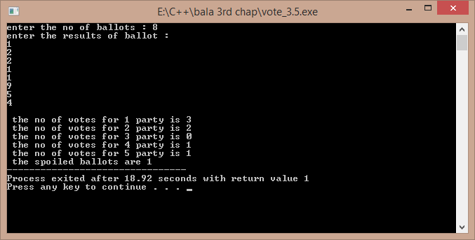

**3.6)**

ALGORITHM:-

1)start

2)create a class which contains the data related to a player and functions

3)create a pointer in the main function to create a array of objects using new operator

4)input the values for each object and print them in a tabular form with the batting average

5)end

/*A program to tabulate the details of the cricket player with the batting average. Developed by Sekhar Karedla BE ¼ CSE-2,CBIT*/

#include<iostream>

using namespace std;

class player

{

char name[100];

int runs;

int inn;

int t;

float avg;

public:

void getdata();

void display();

};

void player::getdata()

{

cout<<"enter name : ";

cin>>name;

cout<<"enter runs , innings , times not out : ";

cin>>runs>>inn>>t;

}

void player::display()

{

avg=float(1.0*runs/(inn-t));

cout<<name<<"\t\t"<<runs<<"\t"<<inn<<"\t"<<t<<"\t\t"<<avg<<"\n";

}

int main()

{

int n,i;

cout<<"\nenter the number of players : ";

cin>>n;

player *p=new player[n];

cout<<"enter the details of "<<n<<" players : \n";

for(i=0;i<n;i++)

{

p[i].getdata();

}

cout<<"PLAYER NAME\t"<<"RUNS\t"<<"INNINGS\t"<<"TIMES NOT OUT\t"<<"AVERAGE\n";

for(i=0;i<n;i++)

{

p[i].display();

}

return 1;

}

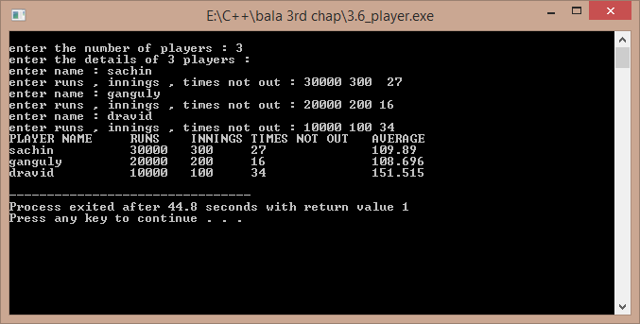

**3.7)a)**

ALGORITHM:-

1)start

2)calculate the original value of sinx using cmath header file

3)calculate the sinx value obtained by eulers expansion

4)find the error and compare

5)end

/*A program to compare the original and obtained value of sinx , Developed by Sekhar Karedla CSE-2 BE ¼ ,CBIT*/

#include<iostream>

#include<math.h>

using namespace std;

int main()

{

long double s,t,x,i,j,n;

cout<<"enter x in degrees : "; //reading the degress

cin>>x;

x=x*(3.141/180);

for(j=3;j<1000;j++)

{s=0;t=x;

for(i=2;i<=j;i++)

{

s=s+t;

t=t*-1*x*x/(2*(i-1)*(2*i-1)); //calculating sinx from euler formula

}

if(((s-sin(x))>-0.00000001)&&(s-sin(x))<0.00000001)

{

cout.precision(10);

cout<<"\nthe original value of sinx is : "<<sin(x);

cout<<"\nthe obtained value of sinx is : "<<s;

cout<<"\nthe order is : "<<j;

break;

}

}

return 1;

}

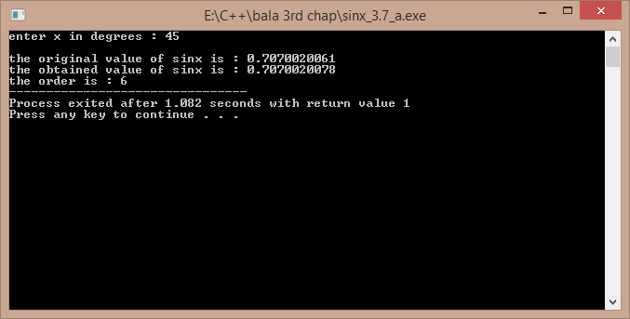

**3.7)b)**

ALGORITHM:-

1)reading the value of x from the user

2)calculating the sum using for loops

3)displaying the result

/*A program to calculate the sum of particular sequence , Developed by Sekhar Karedla CSE-2 BE ¼ ,CBIT*/

#include<iostream>

using namespace std;

int main()

{

float s,k,p,i,j,n,t;t=1;

cout<<"enter N : ";

cin>>n;p=1;

for(i=1;i<=n;i++)

{s=s+p;t=1;

for(j=0;j<i;j++)

{

t=t*(1/(i+1));

}

p=t;

}

cout.precision(10);

cout<<"the sum is : "<<s;

return 1;

}

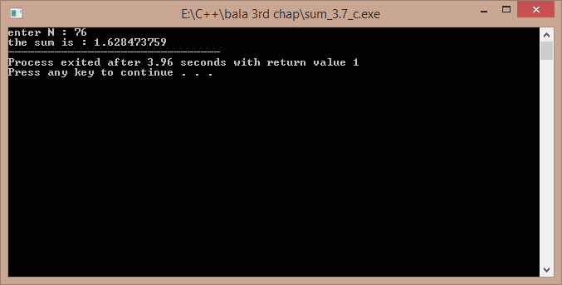

**3.7)c)**

ALGORITHM:-

1)start

2)calculate the original value of cosx using cmath header file

3)calculate the cosx value obtained by eulers expansion

4)find the error and compare

5)end

/*A program to compare the original and obtained value of cosx , Developed by Sekhar Karedla CSE-2 BE ¼ ,CBIT*/

#include<iostream>

#include<math.h>

using namespace std;

int main()

{

float x,t,s,i,j;

cout<<"enter x in degrees : ";

cin>>x;

x=x*(3.141/180);

for(j=0;j<1000;j++)

{

s=1;t=-(x*x)/2;

for(i=0;i<=j;i=i+2)

{

s=s+t;

t=t*-1*x*x/((i+3)*(i+4));

}

if(((s-cos(x))>-0.000001)&&((s-cos(x)<0.000001)))

{

cout.precision(10);

cout<<"\n the original value : "<<cos(x);

cout<<"\n the obtained value : "<<s;

cout<<"\n order : "<<j;

break;

}

}

return 1;

}

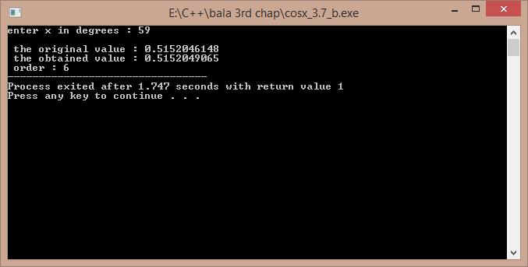

**3.8)**

ALGORITHM:-

1)start

2)we use two for loops for proper alignment

3)we store the results again in a file because viewing the results in the command prompt will cause the failure of alignment

4)we calculate the exp(-x) value for 0.1 increment

5)we store the values in a file

6)end

/*A program developed to show the results of exp(-x) in tabular form , Developed by Sekhar Karedla CSE-2 BE ¼ ,CBIT*/

#include<iostream>

#include<cmath>

using namespace std;

int main()

{

float i,j;float r;FILE *fp;int k;

fp=fopen("result3.8.txt","w"); //opening a file

fprintf(fp,"X");

fseek(fp,1,SEEK_SET);

for(i=0.1;i<=1.0;i=i+0.1) // setting the table headings

fprintf(fp,"\t%f",i);

for(i=0.0;i<10.0;i=i+1.0)

{k=i;

fprintf(fp,"\n%d",k);

for(j=i+0.1;j<=i+0.9;j=j+0.1)

{

r=exp(-j);

fprintf(fp,"\t%f",r); // using fprintf to store the values in a file.

}

}

cout<<"\n the tabular form has been successfully stored in result3.8 .";

return 0;

}

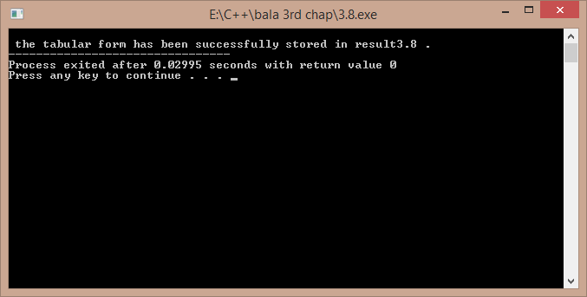

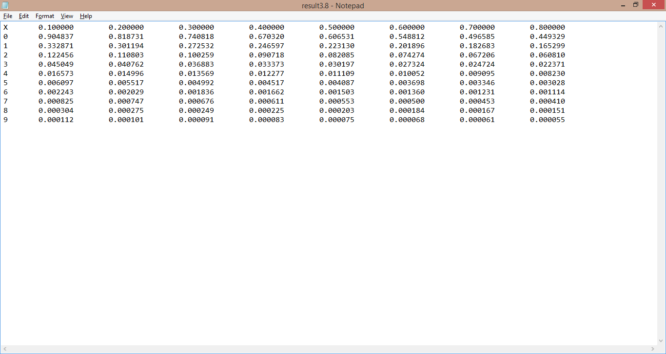

***THE CONTENTS OF THE RESULT3.8.txt:-***

X 0.100000 0.200000 0.300000 0.400000 0.500000 0.600000 0.700000 0.800000

0 0.904837 0.818731 0.740818 0.670320 0.606531 0.548812 0.496585 0.449329

1 0.332871 0.301194 0.272532 0.246597 0.223130 0.201896 0.182683 0.165299

2 0.122456 0.110803 0.100259 0.090718 0.082085 0.074274 0.067206 0.060810

3 0.045049 0.040762 0.036883 0.033373 0.030197 0.027324 0.024724 0.022371

4 0.016573 0.014996 0.013569 0.012277 0.011109 0.010052 0.009095 0.008230

5 0.006097 0.005517 0.004992 0.004517 0.004087 0.003698 0.003346 0.003028

6 0.002243 0.002029 0.001836 0.001662 0.001503 0.001360 0.001231 0.001114

7 0.000825 0.000747 0.000676 0.000611 0.000553 0.000500 0.000453 0.000410

8 0.000304 0.000275 0.000249 0.000225 0.000203 0.000184 0.000167 0.000151

9 0.000112 0.000101 0.000091 0.000083 0.000075 0.000068 0.000061 0.000055

**3.9)**

ALGORITHM:-

1)start

2)take the number of numbers input and create an array with new operator

3)input all number and take their sum , and hence calculate mean

4)use loops to calculate the variance by taking the difference from the mean

5)display the results

6)end

/* A program to calculate the standard deviation , variance , mean of the given numbers . Developed by Sekhar Karedla CSE-2 BE ¼ ,CBIT*/

#include<iostream>

#include<math.h>

using namespace std;

int main()

{

int n,s=0;

cout<<"enter the number of numbers : ";

cin>>n;

int *p=new int[n];

int i;

cout<<"enter "<<n<<" numbers : ";

for(i=0;i<n;i++)

{

cin>>p[i];

s=s+p[i];

}

float m,sd,v;

m=(1.0/n)*s;

float s1;

for(i=0;i<n;i++)

{

s1=s1+((p[i]-m)*(p[i]-m));

}

sd=sqrt(s1);

v=sd*sd;

cout<<"\n\nvariance : "<<v<<"\nstandard deviation : "<<sd<<"\nmean : "<<m;

return 1;

}

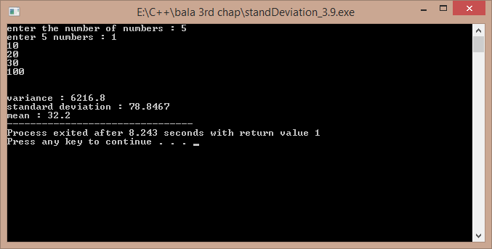

**3.10)**

ALGORITHM:-

1)start

2)input the number of units

3)use the given rates to compute the rate using if elseif statements

4)end

/* A program to calculate the current bill by the input of current units. Developed by Sekhar Karedla CSE-2 BE ¼ ,CBIT*/

#include<iostream>

using namespace std;

int main()

{

float u,sum;

cout<<"enter the units : "; //entering the units

cin>>u;

if(u<100)

{

sum=u*60;

}

else if(u>100&&u<=300)

{

sum=(100*60)+(u-100)*80; //calculating the bill

}

else

{

sum=(100*60)+(200*80)+(u-300)*90;

}

sum=sum/100;

cout<<"the bill amount is : "<<sum<<" rupees";

return 1;

}

